Worksheet 2.1

Student Name: Ayush Yadav UID: 25IMC13004
Branch: MCA (AI & ML) Section/Group: MAM-1 (A)
Semester: II Date of Performance: 23/02/26
Subject Name: Machine Learning Lab Subject Code: 25CAP-672

1. Aim:
Write a program for Support Vector Machine using python.
2. Objective:
To implement a Support Vector Machine (SVM) algorithm using Python and scikit-learn library for classification of a dataset, and to evaluate its performance using accuracy and other performance metrics.

3. Coding:
import numpy as np
import pandas as pd
import matplotlib.pyplot as plt
from sklearn.svm import SVC
from sklearn.model_selection import train_test_split
from sklearn.preprocessing import StandardScaler
from sklearn.metrics import accuracy_score, confusion_matrix

data = pd.read_csv("Social_Network_Ads.csv")

X = data[['Age', 'EstimatedSalary']].values
y = data['Purchased'].values

X_train, X_test, y_train, y_test = train_test_split(
X, y, test_size=0.3, random_state=42
)

scaler = StandardScaler()
X_train = scaler.fit_transform(X_train)
X_test = scaler.transform(X_test)

model = SVC(kernel='linear')
model.fit(X_train, y_train)

y_pred = model.predict(X_test)

accuracy = accuracy_score(y_test, y_pred)
print(f"Accuracy: {accuracy:.2f}")

print("Confusion Matrix:")
print(confusion_matrix(y_test, y_pred))

x_min, x_max = X_train[:, 0].min() - 1, X_train[:, 0].max() + 1
y_min, y_max = X_train[:, 1].min() - 1, X_train[:, 1].max() + 1

XX, YY = np.meshgrid(
np.arange(x_min, x_max, 0.01),
np.arange(y_min, y_max, 0.01)
)

Z = model.predict(np.c_[XX.ravel(), YY.ravel()])
Z = Z.reshape(XX.shape)

plt.contourf(XX, YY, Z, alpha=0.3)
plt.scatter(X_train[:, 0], X_train[:, 1], c=y_train, edgecolors='k')
plt.title("SVM Decision Boundary (Linear Kernel)")
plt.xlabel("Age (Scaled)")
plt.ylabel("Estimated Salary (Scaled)")
plt.show()

OUTPUT:-

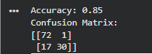

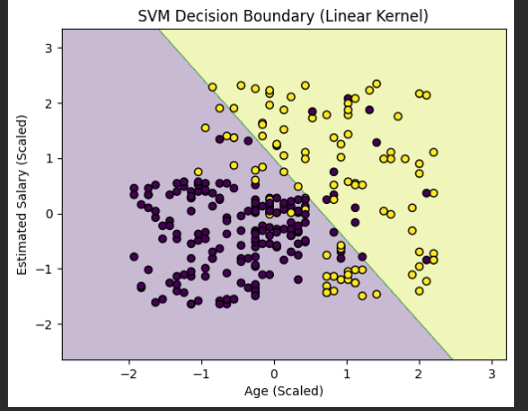

3. Learning outcomes (What I have learnt):
- Acquire practical understanding of fundamental Python libraries including NumPy, Pandas, Matplotlib, and Scikit-learn for data preprocessing, analysis, and visualization.
- Load, preprocess, and explore a real-world classification dataset using Pandas, and identify relevant independent variables (Age and Estimated Salary) for predictive modeling.
- Develop conceptual understanding of Support Vector Machine (SVM) as a supervised learning algorithm and its role in solving binary classification problems by constructing an optimal separating hyperplane.
- Implement an SVM classifier using the Linear Kernel, including proper feature scaling through Standardization to enhance model performance and ensure fair feature contribution.
- Visualize the SVM decision boundary to examine how the model differentiates between purchasing and non-purchasing customers.

